Fix below error

Error occurred during SQL script execution

Reason:

SQL Error [1427] [42000]: For float(M,D), double(M,D) or decimal(M,D), M must be >= D (column 'Discount').

CREATE TABLE Product (

ProductID INT AUTO_INCREMENT PRIMARY KEY,

ProductName VARCHAR(255) NOT NULL,

ImportPrice INT NOT NULL,

ListPrice INT NOT NULL,

Quantity INT NOT NULL,

Discount DECIMAL(1, 2),

AddedDate DATE,

SupplierID INT,

ProductType VARCHAR(50),

FOREIGN KEY (SupplierID) REFERENCES Supplier(SupplierID)

);

Ans1:

The error you're seeing is due to the data type **DECIMAL(1, 2)**. This means you're trying to define a decimal column where the total number of digits (**M**) is 1 and the number of digits after the decimal point (**D**) is 2. However, **M** must be greater than or equal to **D**.

To fix the error, you need to increase the value of **M**. If you want 2 digits after the decimal point and up to 1 digit before the decimal point, then **M** should be at least 3 (**M = D + 1** at a minimum).

Here's the corrected table definition:

CREATE TABLE Product (

ProductID INT AUTO_INCREMENT PRIMARY KEY,

ProductName VARCHAR(255) NOT NULL,

ImportPrice INT NOT NULL,

ListPrice INT NOT NULL,

Quantity INT NOT NULL,

Discount DECIMAL(3, 2),

AddedDate DATE,

SupplierID INT,

ProductType VARCHAR(50),

FOREIGN KEY (SupplierID) REFERENCES Supplier(SupplierID)

);

In the corrected version, I've changed **Discount** to **DECIMAL(3, 2)**. This allows for values like 0.25, 1.00, etc., representing 25% and 100% discounts, respectively.

Ans2:

To fix the error message "For float(M,D), double(M,D) or decimal(M,D), M must be >= D (column 'Discount')", you need to make sure that the precision of the Discount column is greater than or equal to the scale. In the given SQL script, the precision is 1 and the scale is 2, which is causing the error.

To fix the error, you can change the Discount column to have a precision of at least 2. For example, you could change it to DECIMAL(2, 2).

CREATE TABLE Product (

ProductID INT AUTO_INCREMENT PRIMARY KEY,

ProductName VARCHAR(255) NOT NULL,

ImportPrice INT NOT NULL,

ListPrice INT NOT NULL,

Quantity INT NOT NULL,

Discount DECIMAL(2, 2) NOT NULL,

AddedDate DATE,

SupplierID INT,

ProductType VARCHAR(50),

FOREIGN KEY (SupplierID) REFERENCES Supplier(SupplierID)

);

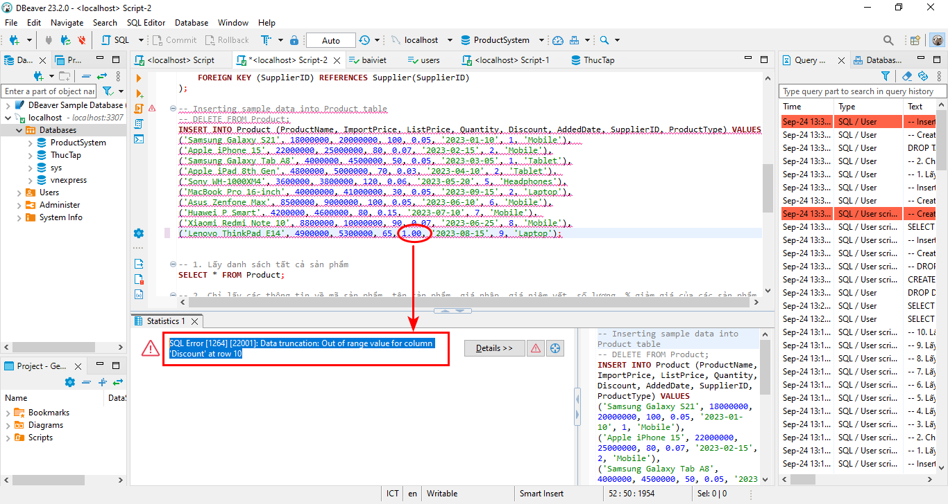

SQL Error [1264] [22001]: Data truncation: Out of range value for column 'Discount' at row 10